Ecomuseo Regionale Lis Aganis
Via Maestri del lavoro, 1
33085 Maniago (Pn)
Tel. 0427.764425 - Fax 0427 737682
Chiara 393 9494762
info@ecomuseolisaganis.it
www.ecomuseolisaganis.it

Pradis – Inside the Prehistory’s Valley !

From the 2nd to the 5th August 2018
H 15.00 Meeting point: Museum of ironwork art and cutlery work – Maniago
H 16.00 Meeting Point: entrance of the Pradis’ Cavern

Min. group 10 persons (cumulative participation) - € 7,00 per person
The Cave Museum of Pradis di Sotto is articulated in one and only opened space exhibition room that gives an overview of the cave’s ambience. The route starts with a reconstruction of the cavern’s bear, whose remains were found in the cavities near the Pradis’ Cave, to continue with an exhibition of archaeological finds and bone remains (deer, marmot, badger) in reference to a patronage from the beginning of 10.000-9.000 b.C. till almost the IV-V th century a.C. The exhibition ends with a rich italian incoming collection of minerals mixed with fossils of local origins, one of the even belonging to the paleontological age.  Guided Tours at Pradis’ Caverns  One of the first explorations were done during the ‘50es but only in 1964 the area was recognized as a place of worship and tourist attraction, thanks to the local parson’s commitment Don Terziano Cattaruzza. What we can find now is the outcome of a long hard done by the parson and the long local community. Madonna’s Cave is the biggest cavity, that hosts within the bronze Madonna’s statue.  Leaving Madonna’s Cave, you get in a metal scructure that brings you on the top of the gorge. Passing trough the cavity, you get the sense of the naturalistic appearance you have around. It becomes a curious way, especially for children, to discover, live and understand the old style life of their ancestors. | 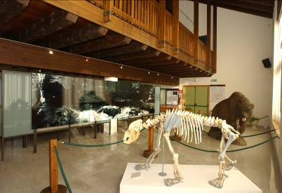  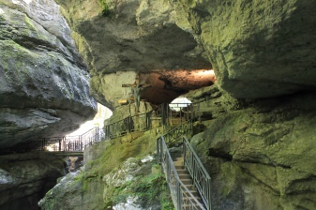
We kindly suggest you to wear mountain outfit, such as trench coat, a cudly blouse and booties… time can suddenly change in the Dolomiti’s Mountains !!

For more info’s or booking: untill the 30th of July 2018
Maniago’s Tourist office - Museo dell'Arte Fabbrile e delle Coltellerie
Tel +39 0427 709063 - coricama@maniago.it

Lis Aganis - Ecomuseo Regionale delle Dolomiti Friulane
Cell +39 393 9494762

N.B. Wheelchairs friendly.

