Ecomuseo Regionale Lis Aganis
Via Maestri del lavoro, 1
33085 Maniago (Pn)
Tel. 0427.764425 - Fax 0427 737682
Chiara 393 9494762
info@ecomuseolisaganis.it
www.ecomuseolisaganis.it

The beauties of Tramontina Valley

From the 2nd to the 5th August 2018
H 17.00 Meeting point: Museum of ironwork art and cutlery work – Maniago
H 17.30 Meeting Point: After Colvera’s Valley gallery

Min. group 10 persons (cumulative participation) - € 10,00 per person

In 2014 the puddles named “Pozze smeraldine” were been included in the special ranking of the 10 best swimming places in Italy. They are located along the patway that starts from “Tramonti di Sopra” to end in “Frassaneit”. They beautifully represent the several natural pools that we can find in different points along the river “Meduna”. Going back to Tramonti di Sopra, there’s also the possibility to run across a small part of this patway (with our operator.  From 2007, the association “Pro Loco” and the Municipality of Tramonti di Sopra, charged an italian artist group about twenty murals. Through those image creations, they had to rappresent ancients crafts and mountains scenes. For example, in the main square, one of the murales is on the Tramonti’s old bakery. Another representation, an image of the shoemaker, can be admired on a private house that was moreover the dwelling of the old historical tailor of the village that can be seen also from the highway that brings to “Monte Rest”.  Transfer to “Tramonti di Sotto”: artistically important is the “Pieve di Santa Maria Maggiore”, holy building of end of ‘400. Here, in the antique choir ,is preserved one of the most interesting cycles of frescoes of the mountains of the province. These frescoes are attributed to “Gianpietro da Spilimbergo” ( begin of XVI century).  Near the “Pieve” it can be seen the Necropoli dating the high Middle age. It was discovery casually in Tramonti di Sotto, but really all the Val Tramontina didn’t find archeological testimony. The place was known mostly for his natural pristine environment ,for his forestry and pastoral activities typical of the mountain ( structrured and regulated by the “Serenissima Repubblica di Venezia” from the XVII century), for some typical kinds of handicraft (basket weavers , sawyers, tinsmiths).  The fortuitous find of the high Middle age Necropoli represents now an important information that help us to rediscover the habits of old inhabitants of Val Tramontina. An extensive excavation ( more or less meters 6*6 *5 of depth) for the construction of a trellis of electricity on the terrace north from Pieve di S.Maria (XII century) allowed in 1990 the recovery of a discreet number of kit items (knives, buckles and earrings) and human bones of burials dating the Longobard age (VII century d.C.)  It will be visit as well the Knowledge House, the old dairy, where you can still admire the objects and istruments that were used in the past to produce cheese; cheese that you can still taste and buy from the dairy owner Amanda, so go for it!  Last but not least, we will end with an italian aperitive: full of traditional tasting flavours, you will never forget this experience! | 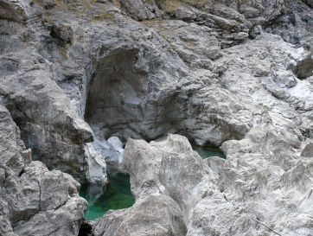  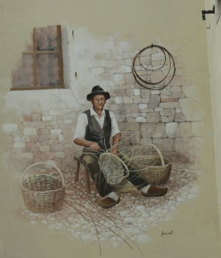  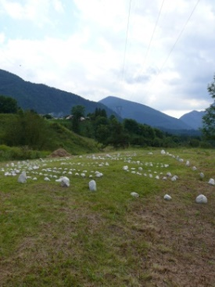  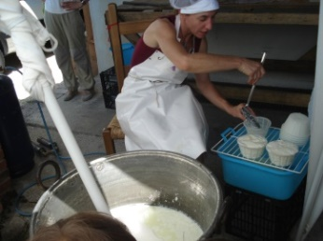
We kindly suggest you to wear mountain outfit, such as trench coat, a cudly blouse and booties… time can suddenly change in the Dolomiti’s Mountains !!

For more info’s or booking: untill the 30th of July 2018
Maniago’s Tourist office - Museo dell'Arte Fabbrile e delle Coltellerie
Tel +39 0427 709063 - coricama@maniago.it

Lis Aganis - Ecomuseo Regionale delle Dolomiti Friulane
Cell +39 393 9494762

N.B. Wheelchairs friendly.

