Ecomuseo Regionale Lis Aganis
Via Maestri del lavoro, 1
33085 Maniago (Pn)
Tel. 0427.764425 - Fax 0427 737682
Chiara 393 9494762
info@ecomuseolisaganis.it
www.ecomuseolisaganis.it

Colvera’s Valley: Tales of waters and fairies

From the 2nd to the 5th August 2018
H 17.00 Meeting point: Museum of ironwork art and cutlery work – Maniago
H 17.30 Meeting Point: after the Colvera’s Valley gallery
Min. group 10 persons (cumulative participation) - € 7,00 per person
Colvera’s Valley, a story to be told !  One of the first things you have to visit is Poffabro, one of Colvera’s Valley village that in 2002 joined the Club of the “Most beautiful villages of Italy”. This old town is characterized by a very spontaneous architecture, made by 4-storey stone buildings with wooden galleries and arches. After walking among the glimpses of Poffabro while getting to know its history, from the central square you will admire ad unique view that gives on all the Valley.  AS A CRAZY ENDING, HAVE A WALK AMONG THE LANDRI’S WILD NATURE!  The origins of the toponym’s place derives by the presence of its cavities: in the local dialect “Ladri” means “cave/cavern”. On another hand, an old leggend tells us about the presence of aquatic nymphs that in some way vivified the valley during the night. The rest of the story will be told during the walk, used as a vehicle to discover this mysterious and fascinating place.  Is the Colvera’s river that, with the strengh of its waters, digged the caverns as “Bus da Li Anguani”; its high is around 15 meters and is on the west side of the Lorenzo’s Mountain. Right a bit under the big cave we find a smaller one named “Spiramont’s cavern” because of a napoleonic deserter that has hidden himself there. As well, is where the first human settlements took place because of a high presence of water and animals to hunt or to fish. Those places now are known as “Landri Scur” and “Landri Viert” and are the wildest parts of the Colvera’s Valley.  last but not least, we will end with an italian aperitive: full of traditional tasting flavours, you will never forget this experience ! | 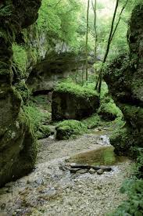  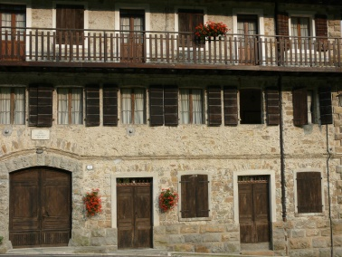
We kindly suggest you to wear mountain outfit, such as trench coat, a cudly blouse and booties… time can suddenly change in the Dolomiti’s Mountains !!

For more info’s or booking: untill the 30th of July 2018
Maniago’s Tourist office - Museo dell'Arte Fabbrile e delle Coltellerie
Tel +39 0427 709063 - coricama@maniago.it

Lis Aganis - Ecomuseo Regionale delle Dolomiti Friulane
Cell +39 393 9494762

