Ecomuseo Regionale Lis Aganis
Via Maestri del lavoro, 1
33085 Maniago (Pn)
Tel. 0427.764425 - Fax 0427 737682
Chiara 393 9494762
info@ecomuseolisaganis.it
www.ecomuseolisaganis.it

Archeological traces around Montereale Valcellina

From the 2nd to the 5th August 2018
H 15.00 Meeting point: Museum of ironwork art and cutlery work – Maniago
H 15.30 Metting Point: Montereale Valcellina’s Archeological Museum

Min. group 10 persons (cumulative participation) - € 12,00 per person
Welcome and presentation of the territory  Departure by yourself to Montereale Valcellina  The Archaeological Museum of Montereale Valcellina (MAMV), placed in the prestigious seventeenth edifice of Toffoli Palace, exposes archaeological materials found after an intense dig activity done on the communal territory during the last twenty years of 1900.  The researches, guided by Friuli Venezia Giulia’s Supervision for Archaeological Heritage, have shown a series of artifacts that attest the use of the area in a continuative way since the recent Bronze age (XIV century a.c.) till nowadays, with up and down intensity level.  Between various phases of occupation of the site the most significant is a dwelling of Fifth century a.C. with the discover of Dolii’s House.  Swords and weapons offered to waters, big decorated vessel, traces of dwellings and craft activity, metal jewelry are only a little part of finds that reminds us a stage of a fascinating past journeys.  Tour visits to the Malnisio’s Hydroelectric power-plant Museum “Antonio Pitter”, jewel of industry architecture where there are guarded the machines still intact, the equipment and the tools of the hydroelectric industry of the last century. In the 1988, the plant stopped to work and starts the idea of making it the venue of a national museum for the electrical energy production.  The Association “Friends of Malnisio’s Station”, partner of Ecomuseum “Lis Aganis”, has the objective of valorising and conservation of this important archaeological industry site. This association will accompany us to this charming journey, talking about stories of machines, waters and men.  The ring route measure 2500 m with a difference in level of 50 m. It is only pedestrian and easily walking. In two stretches more or less 400 m) the path is on the wall of the adduction channel horned of protections. The start of the path outside of the hydroelectric power-plant of Malnisio near a green equipped area thereabout a large lorry bridge.  Along the route you can admire a part of the wonderful works built between 1900 and 1905 to catch Cellina’s waters and exploit their power to produce electric energy - outlet gallery on the plain, adduction channel, desanding basin or brimming, spillway, loading dock, forced pipeline - building of the Malnisio’s Station. In addition to engineering aspects we have to consider the naturals one: in 1988, after the stop of the energy production, the channel and the basins area has not been maintained; with a multiannual operation promoted and implemented by Legambiente Circolo Prealpi Carniche of Montereale Valcellina, these places, since a couple of years, are visible and new tourist destination.  Appetizer with tasting of flavors of the tradition. | 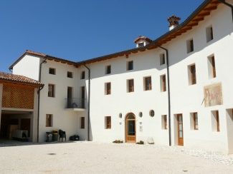  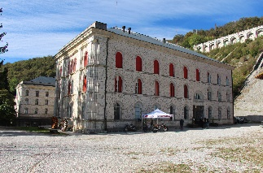  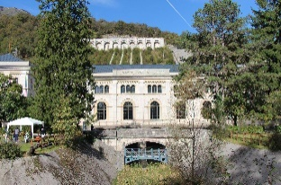
We kindly suggest you to wear mountain outfit, such as trench coat, a cudly blouse and booties… time can suddenly change in the Dolomiti’s Mountains !!

For more info’s or booking: untill the 30th of July 2018
Maniago’s Tourist office - Museo dell'Arte Fabbrile e delle Coltellerie
Tel +39 0427 709063 - coricama@maniago.it

Lis Aganis - Ecomuseo Regionale delle Dolomiti Friulane
Cell +39 393 9494762

N.B. Wheelchairs friendly.

