Ecomuseo Regionale Lis Aganis
Via Maestri del lavoro, 1
33085 Maniago (Pn)
Tel. 0427.764425 - Fax 0427 737682
Chiara 393 9494762
info@ecomuseolisaganis.it
www.ecomuseolisaganis.it

Andreis, a community rich of memories!

From the 2nd to the 5th August 2018
H 17.00 Meeting point: Museum of ironwork art and cutlery work – Maniago
H 17.30 Metting Point: Andreis’ Square

Min. group 10 persons (cumulative participation) - € 7,00 per person
The tour starts from the central square going up for about 200m until getting to the raptor recovery centre: there you have the chance to look/observe closely the wild animals and at the same time to learn more about them. The diurnal and nocturnal raptors mostly get there from all around the Dolomiti’s Park or from neighboring areas. The species that are hospitalized frequently are: hawks, goshawks, tawny howls and golden eagles.  Instead of visiting the recovery centre, if you continue to go up on the dirt road, after not too much you get to the Periadrial Fault, an important tectonic dislocation that passes by, from east to west, the whole Friuli’s Region.  Going back town, we stop to a small blacksmith's laboratory, alla “Favria”, that still works in an old-school way and he preserves the tools of the trade.  The guided tour ends with a visit at the Ethnographic Museum, where we find the story of Andreis’ old living life using the reconstructions of old environments. A considerable importance is given to the past trades, from the bone processing feature to the traditional wood one, needed to bear the workday life of the Andreis’ community. | 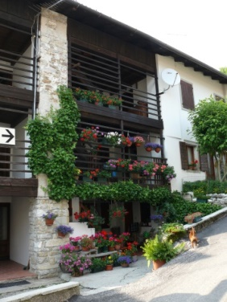  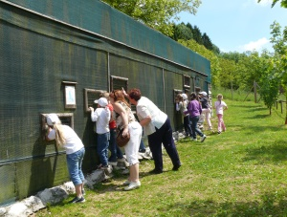  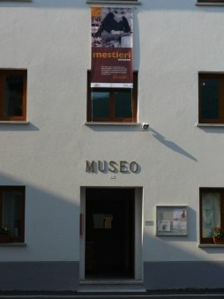
We kindly suggest you to wear mountain outfit, such as trench coat, a cudly blouse and booties… time can suddenly change in the Dolomiti’s Mountains !!

For more info’s or booking: untill the 30th of July 2018
Maniago’s Tourist office - Museo dell'Arte Fabbrile e delle Coltellerie
Tel +39 0427 709063 - coricama@maniago.it

Lis Aganis - Ecomuseo Regionale delle Dolomiti Friulane
Cell +39 393 9494762

N.B. Wheelchairs friendly except in the recovery centre.

